RIT Clubs Policies & Procedures Handbook





CLUB CENTER CONTACT INFORMATION
Club Center
Main Number: Desk Attendant
crcccl@rit.edu
475-7058

Sarah Griffith
Assistant Director for Clubs & Community Outreach
sbgccl@rit.edu
475-6128

Melissa Waughtel
Club Graduate Assistant (GA)
clubs@rit.edu
475-4483

Aksa Asgher
Club Student Assistant (SA)
clubsa@rit.edu
475-4483

Robin Amico
Financial Coordinator
rxsrla@rit.edu
475-5658

Dawn Rizzo
Assistant Financial Coordinator
darccl@rit.edu
475-5798

Carol Giuliano
Clubs Budget Assistant
cagccl@rit.edu
475-6072

Becca Delaney
Coordinator for Marketing & Event Services
radccl@rit.edu
475-7651

Kathleen Hall
Student Government Office Manager
kahhcc@rit.edu
475-2204

QUICK RESOURCES AND REFERRALS

Club & Advisor Issues
Sarah Griffith, 475.6128, sbgccl@rit.edu

Club Recognition | Club Review Board
Clubs Graduate Assistant, 475.4483, clubs@rit.edu

Competitive Sports Club Federation
Clubs Graduate Assistant, 475.4483, clubs@rit.edu

Additional Funding – Student Government | Club Travel
Dawn Rizzo, 475.5798, darccl@rit.edu

Club Budget Questions
Carol Giuliano, 475.5798,cagccl@rit.edu

Event Registration Procedures | Marketing
Becca Delaney, 475.7651, radccl@rit.edu

Leadership Training – RLI
Molly McGowan, 475.6171, mtmccl@rit.edu

Risk Management
Melinda Ward, 475.6135, mjwrmss@rit.edu

Van Usage – Student Government
Kathy Hall, 475.2204, kahhccl@rit.edu

CLUB IMPORTANT DATES | 2013-2014
Wednesday, August 28, 2013 | Club Center Open House (for staff, faculty & students)  5:00PM-6:00PM, Club Center| Come see the updates we’ve made!
Friday, September 13, 2013 | ** Club Waivers DUE by 4:30PM TO:  Event Registration Office, Campus Center (Welcome Desk)  *For sports clubs and active clubs with risk assessment
Friday, September 13, 2013 | Club Interest Fair#1  SAU Lobby, 10:00AM-4:00PM | Email clubs@rit.edu for a table
Wednesday, September 18, 2013 | **Clubs A-L MANDATORY All-Clubs Meeting  2610/2650 Campus Center /2650, 6:00PM-7:30PM  Attendance is MANDATORY (one member per club) - PIZZA PROVIDED!
Monday, September 23, 2013 | **Clubs M-Z MANDATORY All-Clubs Meeting  2610/2650 Campus Center, 6:00PM-7:30PM  Attendance is MANDATORY (one member per club) - PIZZA PROVIDED!
Monday, September 30, 2013 | **Link Profile Must Be Completed  thelink.rit.edu | Email clubs@rit.edu for more information
Friday, October 11, 2013 | Brick City Club Showcase  SAU Cafeteria, 10:00AM-3:00PM | Email clubs@rit.edu for a spot
Friday October 18, 2013 | ** Club Recognition Packets Due (Required)  (online only at thelink.rit.edu)
Friday, October 25, 2013 | Club Interest Fair #2  SAU Lobby, 10:00AM-4:00PM | Email clubs@rit.edu for a table
Monday, December 9, 2013 | **Clubs A-L MANDATORY All-Clubs Meeting  2610/2650 Campus Center, 6:00PM-7:30PM  Attendance is MANDATORY (one member per club) - PIZZA PROVIDED!
Wednesday, December 11, 2013 | **Clubs M-Z MANDATORY All-Clubs Meeting  2610/2650 Campus Center, 6:00PM-7:30PM  Attendance is MANDATORY (one member per club) - PIZZA PROVIDED!
Friday, January 24, 2014 | Club Interest Fair #3  SAU Lobby, 10:00AM-4:00PM | Email clubs@rit.edu for a table
Friday, February 21, 2014 | 3rd Annual Clubs Got Talent  Ingle Auditorium, 6:00PM-8:00PM  Enter your club for a chance to win $500 AND MORE!
Monday, March 3, 2014 | **Clubs A-L MANDATORY All-Clubs Meeting  2610/2650 Campus Center, 6:00PM-7:30PM  Attendance is MANDATORY (one member per club) - PIZZA PROVIDED!
Thursday, March 5, 2014 | **Clubs M-Z MANDATORY All-Clubs Meeting  2610/2650 Campus Center, 6:00PM-7:30PM  Attendance is MANDATORY (one member per club) - PIZZA PROVIDED!
Friday, March 21, 2014 | LAST Club Interest Fair (#4)  SAU Lobby, 10:00AM-4:00PM | Email clubs@rit.edu for a table
Tuesday, April 8, 2014 or  Wednesday, April 16, 2014 | Budget Proposal Information Sessions  2610/2650 Campus Center, 4:30PM-5:30PM
Thursday, April 17, 2014 | Club Bash Award Ceremony  Ingle Auditorium, 5:00PM-7:00PM | Includes 2013-14 club award winners & dinner!
Friday, May 2, 2014 | Budget Proposals DUE by 4:30PM Via Email  *Details TBD closer to due date*
What Does “Club Recognition” Mean?
Recognition is an official status given to RIT clubs who wish to function with the support of Student Government and Campus Life. It grants certain privileges and responsibilities, and these privileges are granted with the assumption that the organization acts within and complements RIT’s mission, vision, and values.

The President of RIT, as the chief administrative officer on the campus, or his/her designee (such as the Vice President of Student Affairs), may grant or withdraw Recognition from any campus organization.

Recognition requires that each group must agree to carry on their activities in a manner that complies with RIT’s Student Rights and Responsibilities, SG regulations and does not violate federal, state, or local laws. Official Recognition can be refused or revoked at any time if the group (but not limited to):
- Contradicts the objectives and mission of SG and/or RIT, or the spirit of these Guidelines;
- Engages in activities that interfere with normal activities of the Institute or the rights of others within the Institute;
- Partakes in activities that present danger to property, personnel and/or functions of the Institute;
- Refuses to comply with federal or state laws, or Institute rules and regulations.

Privileges Associated with Recognition
Recognition includes but is not limited to the following privileges:
- Use of the RIT name as part of its organizational name
- Affiliation with RIT programs and activities
- Requesting of Institutional funds and opening of an Institute financial account
- Use of Institute space, equipment, services and other resources as deemed appropriate
- Access to administrative services as provided by Campus Life & Student Government
- Listing in Institute publications
- Access to leadership training materials and resources
- Sponsorship/promotion of activities on campus
- Distribution of literature, flyers or organizational print materials on campus
- Eligibility for campus awards or honors

Limitations of Recognition
Recognition of a student organization by RIT does not:
- Allow the organization to act as an agent of RIT;
- Authorize the organization to enter into contracts or otherwise act on behalf of RIT;
- Authorize the organization to use:
  - The Institute’s name for any commercial purpose or in any way, written or spoken, which may reflect adversely upon the Institute
  - The Institute’s logo or any copyrighted symbol of RIT. (Such uses of the name or symbols owned by the Institute are allowed only when authorized by the Center for Campus Life or its designee.)
  - Imply RIT sponsorship of, control over, or responsibility for the activities of the organization
  - Allow for separate club budgets or accounts outside of the Student Government account issued in the Club Center

RIT Club Guidelines

A. Criteria for Student Government Club Recognition
Student Government requires that all groups applying for SG Club Recognition must meet the following criteria prior to receiving the Official Recognition of SG and/or other benefits thereof.

- SG Recognition may be granted to student sponsored organizations pursuing activities that will contribute significantly to the intellectual and social development of the student body, serve the education and access goals of the Institute, encourage student participation and leadership, and enhance the general campus environment.
    - The following groups are not considered to be eligible for SG Club Recognition:
      - Unions (bargaining units)
      - Greek letter social organizations or any organization with selective membership
      - College/Departmental student councils or advisory groups
      - Groups that are already served through our offices/departments/missions on campus
- SG will only grant Recognition to one group for any given interest. Proposed groups sharing similar interests and constitutional goals with a recognized group will be encouraged to cooperate with the recognized group to promote their common interests.
- Students wishing to organize club sports groups are subject to these guidelines in addition to those procedures as specified in the Club Sports Guidelines.

For a comprehensive listing of how to Form a Club on RIT’s campus please visit: http://campuslife.rit.edu/main/form_club/index

B. Membership
- For the purpose of these Guidelines: the term STUDENT is defined as all students attending RIT who have paid their Student Activities fees for the current semester. RIT students who have successfully appealed their Student Activities fees must be considered ineligible student. RIT faculty, staff and alumni will be considered NON-STUDENTS. RIT Alumni may not hold officer positions or maintain voting privileges within an organization. Alumni members may participate in club events; however access to RIT services through club events may be limited. As well, e-board membership is limited to current full-time students at RIT. Non-RIT community members are not allowed to actively participate in clubs, however they can attend club sponsored events.

- Membership in recognized organizations, including classes of membership, may not be restricted on the basis of race, religion, political beliefs, gender, age, ability, or sexual orientation. Membership must be accessible to all students with a sincere interest in the group.

- Active membership as defined above includes the following privileges and responsibilities: holding office, voting, authorizing and requesting funds, eligibility for awards, ability to represent the organization.

- SG and Campus Life reserve the right to request the current membership list of any recognized group. This list must include all members’ names. Membership lists will be held in confidence except for election purposes, official Student Government or Campus Life business and Institute requests. Lists are updated and required through the Club Center but are not distributed openly. No information, in whole or part, will be released to any party external to RIT without the express written permission of the student group involved. SG maintains the right to publish the group’s contact information and promotional paragraph as recorded in the group’s Application for Club Recognition Packet.

C. Officers
- All club officers must be RIT students in good academic standing (with both RIT and his/her academic department) and may not currently be on a conduct sanction of disciplinary probation or higher and who has paid Student Activities Fees for the current semester. Officers also can ONLY be current full-time RIT students; not alumni/faculty/staff or non-RIT members. The Center for Campus Life will have access to student judicial records in the Office of Student Conduct and Mediation Services for verification.

- RIT Alumni may not hold officer positions or maintain voting privileges within the organizations. Alumni members may participate in club events; however access to RIT services through club events may be limited.

D. Advisors
- Each group is required to maintain an advisor who is a full-time faculty or staff member of RIT. The advisor will be responsible for attending meetings, signing Student Government financial request forms and providing general assistance to the group as outlined in the Advisor’s Manual.

- Students are required to keep their advisors updated and aware of issues – students should be meeting with their advisors, asking for guidance and support, and utilizing them as a resource of RIT policies and procedures.

Club Administrative Requirements

Communicating with Club Staff
From time to time throughout the year, there will be changes within your club. Your advisor might leave RIT or their position, officer transition, a problem goes wrong with your event – you name it! To avoid having your club account frozen or placed on hold please contact our Club Center staff to alert them to the issue or problem at hand, so they may work with you. The staff is very flexible and willing to account for circumstances; however we need communication from the club first to keep aware of what is happening and to not have to assume the worst. Most club issues can be emailed to Sarah Griffith at sbgccl@rit.edu, and for Finance questions and concerns you can email Carol Giuliano at cagccl@Rit.edu

All-Club Mandatory Meetings
All recognized clubs are required to attend the All-Club Meetings unless previously excused by the Assistant Director or Club Graduate Assistant. Notification of absences should be made to the Assistant Director or Club Graduate Assistant at least twenty-four (24) hours prior to the meeting or following the meeting. The Assistant Director or Club Graduate Assistant will give clubs a window of 24 hours to respond as to why they missed a meeting; if notification of absence cannot occur within 24 hours prior (due to emergency purposes) then please notify the Assistant Director or Club Graduate Assistant within 24 hours following the meeting. If no notification occurs, the club will be placed on hold. Club Presidents should attend or appoint a representative from the club to attend. These meetings provide an opportunity for important training and information sharing.

The consequences of missing meetings are:
- Missing one meeting, a hold on the account and a warning issued – to erase the hold the club must contact the Assistant Director or Club Graduate Assistant.
- After missing two meetings all privileges (including budget access) will be suspended pending review by the Assistant Director or Club Graduate Assistant. Two meetings missed without notification to the Club Office could result in the club becoming disabled.

Club Constitution and Club General Email
As of fall 2012, all clubs are required to have an updated Club Constitution and Bylaws on record with the Club Center. This date is listed on the “Important Dates Document”. As well, clubs are required to have a general club email that is not currently the name of a present student within the club, or advisor. This general email will be listed to help newcomers to clubs find ways of reaching and becoming involved. These are free @rit.edu email accounts that can be requested and completed with Sarah through the Club Center and a Computer Account Authorization Form.

Club Review Board
The Club Review Board (CRB) is the student led advisory board which oversees all services, policies and procedures that relate to Student Government’s recognized clubs. The CRB is comprised of student representatives from a variety of SG clubs chaired by a Student Government Representative and advised by the Assistant Director. The CRB meets on a weekly basis to discuss and make decisions regarding club issues. The CRB reviews the SG Club Recognition Process. The Club Review Board provides an opportunity for the interests and concerns of SG’s clubs to be voiced and addressed in a positive and productive manner.

The Club Review Board is an important piece of Student Government’s role in RIT’s shared governance. In addition, it is an excellent leadership opportunity. CRB members gain valuable skills in teamwork, decision-making, and critical thinking, while working to improve campus life at RIT. If you would like to become involved in the Club Review Board, please contact the Center for Campus Life, otherwise each semester eight (8) randomly selected clubs will be identified as being required to have one (1) representative of their organization sit as an active member on the Club Review Board (CRB) for a term of one (1) semester. These specified club representatives will change on a semesterly basis. In an effort to make sure that the clubs are equally represented, the following format will be used to determine the CRB representatives:

3 Hobby/Music clubs
2 Career related clubs
1 Sports club
1 Ethnic club
1 Religious club

If the designated club representative does not uphold their obligations as a CRB member, they will run the risk of their clubs budget being frozen and/or may be required to meet with the Assistant Director or Club Graduate Assistant. All privileges will be suspended until this meeting occurs. Missing 2 meetings requires an individual meeting with the Assistant Director or Club Graduate Assistant as well.

Recognition Renewal
All SG Clubs are required to re-apply for SG Recognition each year during the Fall Semester of each academic year with the submission of an Application for Club Recognition. If a group fails to submit an Application for Club Recognition, their Recognition and subsequent benefits can be suspended. Recognition renewal must take place prior to budget review and allocation. Recognition Applications can be obtained online at clubs.rit.edu.

DVD/Video Copyright Law
Federal copyright law restricts the use of DVDs/videocassettes for private showings and prohibits their public performance without prior written consent of the holder of the copyright. A public performance includes, but is not limited to, showing a motion picture in a location open to the public, showing a motion picture to a selected group of people gathered in a location not open to the public (i.e. residence hall floor or lounge), or showing a motion picture by broadcast or transmission. Student organizations choosing to publicly show a motion picture in any form (film, VHS video, DVD, etc.) must secure a license from a booking agency. Videos or DVDS that are rented or purchased from a retail outlet are for home use only and cannot be shown on campus without the appropriate license from an approved booking agency.

Using Institute Logos
RIT has registered its names, initials, logos, and trademarks as a means of protecting them from unauthorized use and abuse. Permission is required before they may be reproduced. The use of the Institute’s marks on a website or t-shirt is also protected by federal trademark laws. For club t-shirts, all t-shirt designs/logos need to be pre-approved by Sarah Griffith (sbgccl@rit.edu) before ordering. The use of the RIT name is required on all t-shirts, flyers, etc. used when advertising club purposes, and there are restrictions on the RIT tiger as well. The RIT Athletics Tiger is unable to be used by the students without prior approval from University Publications. Please refer to the University Publications page when consulting your group about what is appropriate and what is not.

Club Waivers
Any club that could potentially cause risk or harm to its members or to others is required to fill out a waiver before participating. This includes, but is not limited to: sports clubs (Both competitive and non-competitive), clubs associated with movement and/or dance, clubs that use vehicles in any capacity. These waivers can be found at the Campus Center Welcome Desk and must be filled out by the beginning of the academic year. Anytime that a new member is added to a club roster, they are required to fill out a waiver form as well.

Benefits of Recognition: Club Center
- Bookkeeping | Budget Services
- Free marketing (Campus Life) – and posting of marketing
- Staplers, hole punchers, calendars, Paper cutter, office supply usage
- Club Center mailboxes – and mail can be sent to
- Computer Usage
- 175 free copies, black/white front only – inquire at Club Center
- Reservation of space in the Student Alumni Union free of charge
- Ability to request access to academic meeting and classroom space when available
- Participation in Annual Reservation Process

CLUB RESOURCES & SERVICES

Club Space – SAU: Basement Rooms and Storage Lockers
Club Space is designed to provide meeting, storage and office space for SG Clubs. Club Space is not guaranteed – it needs to be requested through the Club Center. Club Space is located in the basement of the SAU, and there are also lockers available to clubs assigned through the Club Center. Additionally, Club Space is also offered in the Club Center. Club Space is utilized to store club equipment and belongings. You can apply for club space for your club only (not personal use) by emailing clubs@rit.edu with the subject header of “Club Space Request”. Applications will be accepted at any time during the year, however space is limited. If a club is allocated club space, it has 2 weeks to claim it or the space is reissued.

Email Distribution Lists
The Center for Campus Life utilizes an email distribution list for efficient communication with all Clubs. This list is comprised of the names and email addresses of club leaders and members who wish to receive information and updates from CCL and SG. This list typically includes the club’s executive board, however others are welcome! Please remember to provide updates as your club leaders or members change throughout the year. If you have questions about the distribution list or need to have your list updated, please contact Sarah Griffith at sbgccl@rit.edu.

DCE Email Accounts | Club Webpages
Student Government and the Center for Campus Life offer free access to DCE Accounts for SG Club use. Your club or organization can access RIT’s DCE, establish a club email address or create a club page on the RIT Web site. All DCE accounts must be approved by your faculty/staff advisor and account usage must follow RIT’s Code of Conduct for Computer Use. Please stop by the Club Center and see the Assistant Director or Club Graduate Assistant to pick up an application – the Assistant Director must sign off on this application. As of fall 2012, a general club account will be required by all clubs so to advertise for maximum exposure. @rit.edu accounts will be established, however any club that has made an account prior to fall 2012 under another venue (such as @gmail.com) will be allowed.

Club Interest Day Fairs
Throughout the year there are four Interest Day fairs in the SAU Lobby. On these days all your club needs to do is email Sarah at sbgccl@rit.edu letting her know you’d like a table and you have free access to a reservation and table in your name to sit in the lobby from 10:00am-4:00pm to promote your club. You can fundraise during this time, advertise, and learn more about other clubs! These dates will be announced throughout the year.

Club Chat Newsletter
Started in November 2012, the Club Chat Newsletter is a great way to advertise about your club, your sports accomplishments, and showcase pictures of what you’re doing! The newsletter is sent out to Student Government, throughout Campus Life, advertised to our faculty and staff, and to your fellow club students. To be included in the Club Chat Newsletter, which occurs every month, please email clubs@rit.edu – to see previous editions of this newsletter please visit http://campuslife.rit.edu/main/clubs/clubchat

Community Service Referral
The Center for Campus Life provides a community service referral system to all RIT students. Individuals and clubs looking for volunteer opportunities in the Rochester community can contact the Community Service Center at 475-6056 to obtain information regarding community needs, available projects and long-term volunteer positions, as well as general information regarding community service and service learning. Participating in service events is a great to way develop teamwork and commitment among your club members, while gaining valuable skills and helping those in need!

Club Mail Folders
All Recognized SG Clubs are provided with a mail folder located in the Club Center. A Club representative must check this folder weekly in order pick up important SG, CCL and Institute information. Important information including budget statements, meeting announcements and inquiries from students and departments are delivered to these mail folders. Off-campus mail addressed to clubs is placed here as well. Take advantage of this convenient and easy means of communication and be sure to check your folder often!

Free Marketing
As a service to our clubs and organizations, Staff Artist’s are available through Campus Life to complete free marketing requests. Our staff artists design flyers, posters, banners, postcards, business cards, labels, logos, t-shirt design, and much more! This service is free and to request you must access the form at: http://campuslife.rit.edu/main/art_request/displayForm Design alone is done by our artists, however you can also fill out a Promotion Distribution Form at the Club Center Welcome Desk after printing off your own flyers and our staff will hang up the promotions for you around campus free of charge! Even if you already have your design and you just want a flyer made, you can upload your own design as well – and they’ll still hang it!

Free Copies
Each club is provided 175 free copies through the HUB Printing Service during the academic year. These prints are black/white, and one sided. To be able to use this quota you must complete a blue EAF form at the Club Center and mark the box for HUB. This can be done at the Club Center Welcome Desk.

Purchasing Office Supplies
Clubs wishing to purchase office supplies with their SG funds are eligible to receive a discount from Staples. Discounted catalogs are available for club use online, and questions can be directed to the Club Center. To order your supplies, stop by the Club Center for assistance in determining and placing your order.

On-Campus Advertising
- Ben & Jerry’s (inquire at Club Center)
- Campus Center LCD Screens (inquire at Club Center)
- Reporter Ads (ads@reporter.edu)
- WITR Radio Station (stop in to do a free spotlight during lunch on your club/event!)
- Tabling in the SAU (Campus Center Welcome Desk)
- SAU Display Cases (campuslife.rit.edu/evr)
- Window Art in Campus Center (contact Becca Delaney at radccl@rit.edu)

The Link@RIT | Rosters | Profiles
In the Club Center, maintaining and tracking club profiles, membership lists, advisors, holds, and budgets are done through a system called the Link@RIT. This system is updated and maintained by the Club Center staff, but it is the responsibility of the club members themselves to maintain the rosters and profiles for their clubs through this system. Only club e-board members currently listed on the roster may update or access this system; but once access has been granted members should go in to keep track of their rosters, so that the Club Center staff may communicate with the right people when regarding issues or triumphs regarding that individual club. Through this system, clubs can also update their Club profiles, which are accessible to current and prospective students, as well as promote upcoming events, post club documents, message club members, post club photos, and much more! To access this system please go to: thelink@rit.edu and sign in from there.

Wellness Credit: Club Sports
Beginning fall quarter 2012, participation in a club sport or an intramural team will not qualify for a wellness class exemption. Those exemptions that were granted in the past will still count- for example if someone participated in Rugby and was exempt from a wellness class last year, they still will have that one course exemption.

The reasoning for this change, is that while club sports and intramurals certainly may enhance the wellness of the participants- and are encouraged- club sports and intramurals are not taught by qualified instructors, attendance is not necessarily taken and reported, the hours of participation are not necessarily equal to a wellness course, there are no learning objectives, and no assessment methods. In addition, there are no other wellness credits granted by students.

CLUB BUDGETS | FUNDRAISING | REQUESTING FUNDS

All clubs are given a specific account number and budget line through Campus Life; any Student Government awards, student donations, alumni/outside donations, student dues, etc. are deposited into this account. All financial transactions of any nature are required to be run through your club account only, unless funded through an individual department. Clubs are not allowed to have outside checking accounts. At any time a club may request to see the amount that is remaining in their club budget account.

Clubs wishing to find out information about the Budget Process, specifics about how to request, how to appeal to change tiers, etc. can visit: http://campuslife.rit.edu/main/uploads/club_budget_process.pdf

Club Budget Tiers
- If your club is Tier 0 or 1, you do not receive a budget, and depend on fundraising, donations, and dues to grow your club account balance.
- If your club is Tier 2, you must complete the budget process to receive a budget and are awarded up to $400 per year.
- If your club is Tier 3, you must complete the budget process to receive a budget, may be present when your budget is reviewed, and are awarded funds on a case-by-case basis.
- Tier 2 and 3 clubs must be in good standing to be eligible for SG funds and without a club hold.

Matching
President Destler graciously runs a program called “Matching” every year that is a fixed percentage across the board that he is willing to match against student donation. Students are only allowed to put in up to $50 per member, and the range of matching has been from 82%-96% (depending on the year, donations, etc.) This program allows students to put in a certain amount per member that the President will then try to “match” up to a certain percentage to give the clubs extra funding.

Budget Token Programs
To account for Financial Transactions that occur through your Club budget account, for every financial transaction that is completed correctly, on time, etc. you will receive one token in your Club Mailbox. Once you reach ten tokens your club automatically receives $20 into their club budget account. Take advantage of this service – the program is unlimited!

Student Government Finance Committee for Additional Funds
Clubs are able to request Additional Funds through the Student Government Finance Committee. Any questions should be directed to sgfin@rit.edu – to apply for Additional Funds an application can be found in Student Government, or on their webpage. The form can be found online at http://campuslife.rit.edu/main/uploads/application_additional_funds.pdf, printed out and handed in to the Student Government Office. Additional information on the finance process can also be found at http://campuslife.rit.edu/main/clubs/resources .

- Finance Committee will fund:
- Events open to entire RIT community (not including travel)
- Cultural food (must contribute to awareness of culture)
- Up to $500 for banquets
- Up to 50% of travel costs if you are representing RIT directly
- Gas and vehicle rental costs
- Guest speakers, artists, or performers fees and traveling expenses
- Up to $500 for gifts or prizes (Rare circumstances)
- Equipment or material (given have proper storage space)
- Reimbursement for expenses
- Internal services (FMS, ETC, Tech Crew, etc.)
- Support activity for fundraising for charity events

- Finance Committee will NOT Fund:
- Food
- Mileage for personal vehicles
- Uniforms
- T-shirt purchases
- Cash prizes (They are prohibited)
- Tax on a reimbursement
- Reimbursement of an advisor, faculty, staff
- Donations to charity directly

Budget Requests
Every year, clubs that are not Tier 0 or Tier 1 clubs may apply for a budget. The budgets are generally due in May and are noted on the Club Important Dates list at the beginning of the year. To apply for a budget, a budget request form needs to be filled out at http://campuslife.rit.edu/main/clubs/resources but can only be done once a year when the form is updated in the April prior to the due date. The application process closes in May and budgets are no longer able to be submitted. If your club missed the budget request period the club will need to wait until the following year to request funds; funds are not automatically given or awarded from year to year but need to be requested. As well, clubs that are Tier 1 clubs looking to move to a higher tier to request a budget need to be in existence for at least a year, show substantial growth, have run transactions through their Club Budget account, and be able to show the need for funding for events/equipment/etc. Every year, Budget Request Seminars are also held to help students understand how to complete the Budget Request process. Individual appointments during this time of year can also be made at the Club Center.

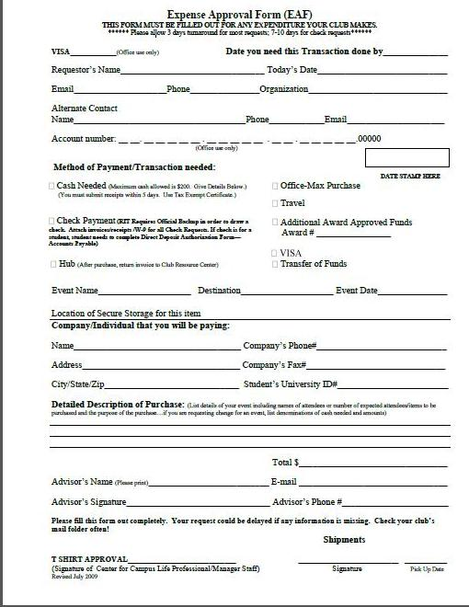
The Fun Club
To be filled out by Club Center
For Reimbursement
To request 175 copies
To sign out Credit Card
Advisor signature is required; Club Center will only allow form to be signed 2 times by Sarah Griffith without
Form needs to be signed by Sarah to order t-shirts

Cash Handling
All fundraising should be deposited during normal daytime work hours in the Club’s account (at the Club Center).There is an after-hours deposit drop box available to SG Recognized Clubs and Major Student Organizations. The after-hours drop box is located in the Campus Center on the A level. It is on the wall to the right of the Center for Campus Life Offices. After-hour deposit envelops are available for depositing the funds within the box. Please complete a deposit form and fill out needed information on the label of the envelope before dropping in the box. Please contact Public Safety at (585) 475-2853 or (585) 475-3333 and request a money escort to the after-hours drop box. The next business day you will receive a receipt in your club mail folder at the Club Center.

Cash Box Security Tips at Special Events

Internal Controls:
Strong internal controls and documented procedures should be in place to ensure cash proceeds are adequately safeguarded, deposited timely and accurately reflected in the general ledger. Following are a few suggestions that you should consider when evaluating and implementing your cash handling procedures at special events on campus.

Safeguard Cash:
Remove temptation for would be thieves by only counting cash and checks in a locked room. All cash should be kept in a secure location. Cash that will be secured in the building overnight could be an attractive target for thieves. Whenever possible, cash should be counted and deposited on the day its received If cash is to be stored overnight (or during the day while unattended), it should be placed into a cash box within a locked cabinet or safe to which there is restricted access. Remember, it is never appropriate to use cash proceeds to make loans, for advances, or to pay for expenditures.

Cash Box Security:
It is very important to secure cash box by a lock. Limit access to the cash box to only one individual. If there are duplicate keys, make sure that you are only allowing people whom you trust and who understand cash handling protocol to hold them in their possession. At all costs, avoid keeping the money in transparent containers. The sight of so much money may prove to be too much temptation for even the most innocent of individuals. Never leave the cash box unattended. Since it’s not possible for you to safeguard the cash box while supervising other facets of the event; ensure that there’s a trusted back-up available to assist you.

Segregate Duties:
Critical controls such as segregation of duties, limited access, and regular reconciliation are important in handling cash. The number of individuals authorized to receive and handle the cash should be limited and supervised. The individual who receives cash should prepare a listing of all incoming cash.

Change the Routine:
Thieves look for patterns of behaviors to identify when it is easiest to steal. Changing who makes the deposit and at what time can throw off a potential thieve. Accompany the person who is transporting money to the Cashier’s Office and make sure it’s enclosed inside a container that does not resemble a cash box.

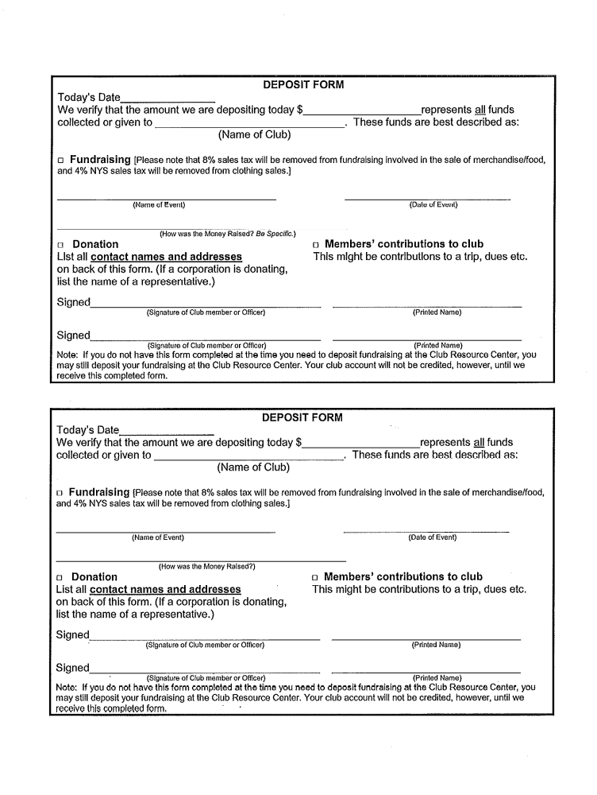
RELIGIOUS CLUB GUIDELINES

Recognition of Clubs
Students who wish to form religious clubs will complete an Application for Club Recognition Form. Prior to the application’s approval by the Club Review Board, the application must be submitted to the Director of the Center for Religious Life for an administrative review and discussion regarding the expectations required for a religious club. As with all clubs, membership must be open to all students, and must be voluntary on the part of the participants.

Recognition for religious clubs will allow the club the same privileges as other student clubs as long as they are not affiliated with any external entities or their staff that has not been approved by the Director of the Center for Religious Life. Advisors for all religious clubs must be full-time faculty or staff members at RIT, unless otherwise approved by the Director of the Center for Religious Life, and the Director of the Center for Campus Life.

Privileges for recognized clubs include free use of space, access to institute resources, permission to use RIT’s name when advertising events, an ability to obtain funds from Student Government and other formalized funders at RIT, and seek a faculty/staff advisor, as listed in the Club Recognition Guidelines. Space requests will be coordinated through the Center for Religious Life, in conjunction with other offices that coordinate room reservations on campus. All religious clubs will be allowed space for one meeting per week on campus, and other special events that are registered and approved by the Center for Campus Life.

Additionally, the student leaders of these organizations will be required to meet with the Director of the Center for Religious Life on a semester basis. The purposes of these meetings are: to discuss their respective programming and meeting calendars: assess their respective needs; facilitate communication to avoid schedule conflicts; and optimally enhance centralized programs. The clubs’ activities and meetings will be arranged into a calendar for the center.

Failure to attend these semester meetings or work cooperatively with the Center for Religious Life may result in revocation of the organizations’ activities and reservations for the semester.

Recognition of Clubs Associated with External Entities
Students may request to form clubs that are affiliated with external entities. These entities are associated with non-denominational college-based programs (i.e. Hillel, Intervarsity Christian Fellowship, Campus Crusade for Christ). These organizations and their relationship to the club MUST be clearly identified at the time of club application. Regional or national meetings with affiliated programs for external constituencies will be considered an external event and referred to Office of Government and Community Relations as a conference. Clubs may not affiliate with or represent denominational or nondenominational institutions (i.e. churches, synagogues, mosques, or organized communities) without the approval of the Director of the Center for Religious Life.
The applications will be reviewed by the Director of the Center for Religious Life and the Assistant Director of Campus Life Programs to assess potential conflict that may occur with institute policies and procedures. External organizations which fail to comply with these standards will not be approved, or may have their recognition rescinded.
Student clubs may not be affiliated with denominational institutions (i.e. churches, synagogues, mosques, traditions, or communities).
CLUB SPORTS GUIDELINES:
COMPETITIVE & NON-COMPETITIVE

There are currently 21 Competitive Sports Clubs administered by the Rochester Institute of Technology’s Center for Intercollegiate Recreation and Intramural Services & Recreation (CIAR) and Center for Campus Life (CCL) and recognized by Student Government (SG). Each club is comprised of enthusiastic, hardworking, and dedicated athletes who organize, fund, and promote their clubs with the ultimate goal of competing against other colleges on both a regional and national level.

Competitive Sports Clubs provide unique opportunities for students to participate, compete, and develop skills in a variety of sports. These clubs actively recruit both new and experienced student athletes during the year, and through weekly practices, prepare for intercollegiate competitions. Competitive Sports Clubs are governed by regulations of both the Department of Intercollegiate Recreation and Intramural Services & Recreation and the Sports Club Federation. Sports club members represent both their club and the Department of Intercollegiate Recreation and Intramural Services & Recreation as well.

The success of the Competitive Sports Club program at RIT is the result of dedicated student leaders volunteering their time, effort, and guidance to their respective clubs. Sport club officers provide strong leadership as well as a vision that carries each club into the new academic year.

Please see the Club Sports Federation Handbook for full guidelines, etc. for Competitive Sports Clubs online at clubs.rit.edu

COMPETITIVE CLUB SPORTS:
- Competitive clubs are only those that are a member of the Sports Federation; they have been elected into the Federation and hold a spot at the table for voting purposes and separate funding from Student Government.
- These clubs are allowed to practice, hold meets/games, compete, and attend nationals throughout the year

NON-COMPETITIVE CLUB SPORTS:
- Even if a club is competitive in that it looks to compete or play against other teams, it can not consider itself competitive UNLESS it is a member of the Sports Federation. As such, limitations are placed on the amount of travel and competition that occurs.
- Policy states that clubs that are not in the Sports Federation are not allowed to compete more than once a semester, the only exception being to attend nationals. Clubs of this nature are also encouraged to go to the Student Government Finance Committee for additional funds

Reserving Space as a Sports Club
Clubs must meet the following requirements before submitting an athletic reservation request:
- Must be recognized as an official club by Campus Life
- Must be in good standing with Campus Life (no holds)
- All liability waivers must be completed and returned to the Event Registration Office
HAZING
RIT is committed to the professional and personal health and wellness of all our college students, especially including our NCAA and club sports athletes. Hazing of any sort will not be tolerated and subject to Judicial Review by the Student Conduct Board. For the complete RIT Hazing Policy please visit http://ritathletics.com/documents/2007/9/10/Hazing%20Policy.pdf . For further information about how to build positive teams, and what to look for with hazing please visit http://ritathletics.com/sports/2007/9/3/atl090307.aspx

Requesting a Van for Transportation

Student Government Vans:
Contact Person: Kathy Hall, 455-2204 (v/tty), e-mail: kahhcc@rit.edu
Parking & Transportation Driver Certification Required: Yes
Fee: Gasoline (Tank must be filled upon return otherwise Parking & Transportation will fill at a cost of $4.50 per gallon. A penalty may also be charged of $25.00)

PATS Vans:
Contact Person: Rick LaClair, 475-7300, email: rllcps@rit.edu
Parking & Transportation Driver Certification Required: Yes
Fee: Van Rental & Gasoline (Van charge is $65/day per van. Tank must be filled upon return otherwise Parking & Transportation will fill at a cost of $4.50 per gallon. A penalty may also be charged of $25.00)

Who Can Use the Vans?
The Student Government (SG) vans are primarily reserved for any club or organization recognized by the Student Government of Rochester Institute of Technology. Vans may also be reserved by other student groups with an account number and advisor’s signature, and for academic trips with departmental approval. All other departments can reserve a van for a fee with the permission of the SG Office Manager or the Director of the Center for Campus Life. In all circumstances, SG recognized clubs and Major Student Organizations (MSO) receive first priority up to 30 days prior to day of use. Requests must be made at least 48 hours in advance to receive a van. Requests are received on a first come, first serve basis.

What policies regarding van reservations must I know?
May check van availability with SG Office Manager prior to completing the EVR.
- Reservation will not be confirmed until the SG Office Manager receives notification from EVR.
- Your organization must have a valid RIT account number.
- Vans may not have more than six passengers and a driver (7 total).
- Vans cannot be taken for more than four days (96 hours) unless permission is given by the SG Office Manager and the Director of the Center for Campus Life or his/her designee.
- At the time of the request, the organization must be in good financial standing with SG.
- Only one van, per group, per request. Second van requests will be granted seven business days before reserved date if van is not needed by another group.
- Vans cannot be driven more than 800 miles round trip unless approved by the Director of the Center for Campus Life. Trips of this distance should be taking place over the course of several days, and not overnight.
- Any trips exceeding 400 miles round trip will require two certified drivers.
- Vans cannot be used to move any personal items or for shuttling.
- Vans must be parked in the Parking & Transportation area behind Grace Watson upon return. They cannot be parked at the residence halls or apartments.
- When the request is for local use, multiple days, vans must be returned to the Grace Watson lot each night.
- The borrowing organization is responsible for all tolls, fines, fees, or damage while using the van except for those incurred by the driver if negligence is shown.
- The driver and organization will lose van privileges after TWO NO SHOWS OR UNVERIFIED CANCELLATIONS. Cancellations must be received 24 hours prior to trips during normal working hours Monday – Friday, (8:30 am – 4:30 pm). Acknowledgement from SG or PATS is either a return phone call or e-mail response. There will be a charge for not cancelling unneeded vans.
- The driver is responsible for notifying the Public Safety supervisor, Parking & Transportation and SG of any accidents or traffic violations that the van was involved in regardless of fault.
- In compliance with New York State Law and RIT policy, the use or possession of controlled substances and alcoholic beverages is prohibited while using the van. There is absolutely no smoking allowed in the van.
- Weather Cancellation: Van reservations may be cancelled by the University without prior notice.
- It is the driver’s responsibility to be aware of the contents of the van contract that is signed when he/she picks up the van.
- Driver must present van certification card and passenger list with emergency numbers at Parking & Transportation or Public Safety before packet will be given.

How do I know my reservation has been confirmed? You will receive an email from Kathy Hall confirming your request, or your request will be confirmed on the EVR message board.

EVENT TRANSPORTION
Transportation for RIT events, activities, and programming can be obtained from two
departments on campus. These departments offer services to student clubs and
organizations, Residence and Apartment Life programmers, and in some cases, faculty
and staff. Campus Safety Driver Certification is Required. For information about
obtaining this certification, contact Jeff Meredith at 475-7300 (v) / 475-4914 (TTY).
Services are provided by the following:

RIT Transportation
Contact: Campus Safety 475-7300 (v)/ 475-4914 (TTY); leave message as to date and time needed; they will call back to confirm reservation.

Who can use: Any RIT Department, College, Student Club or Organization with an RIT account number.

Available: 4 Vans (6 Passenger + Driver); number per request limited to availability
Buses available from outside companies; Campus Safety will handle requests

Fee: Vans are $65/day plus gasoline; 200 free miles per day

Student Government
Contact: Kathy Hall 475-2204 (V/TTY) email: kahhcc@rit.edu

Who can use: Any recognized Student Government Club or Major Organization
(top priority). Vans may be reserved by other student groups with
an account number and advisor’s signature, and for academic class
trips with departmental approval. All other departments can
reserve a van for a fee.

Available: 3 Vans (6 Passenger + Driver); limit of two vans per group per
request

Fee: Gasoline

EVENT REGISTRATION & RESERVATIONS

WHAT IS EVENT REGISTRATION?
Event Registration, also known as EVR, is a process that helps students plan safe and organized activities. It helps students request services and educates students on how to program successful events. The Event Registration Office is located behind the Information Desk in the lobby of the Student Alumni Union (SAU) and is open from 1:00 PM to 4:00 PM Monday through Friday during the academic year. Due to the need for signatures, the initial intake needs to be done in person, and not via phone or email. Events are required to be registered in order to occur (sporting events, fundraisers, etc. – general meetings are not required to be registered). You first have to RESERVE the space though before you can REGISTER!

REGISTRATION OF TRAVEL
• Pick up Travel Applications in Student Government, Campus Life or in EVR.
• Complete the form. It requires details about the event and is also used to request an RIT
Van (via SG or Campus Safety) and to request additional travel funds from Student Government.
• Submit the form to EVR.
• The EVR Intake coordinator will review the form with you and process it similar to a regular on campus event. In most instances we will request that the Responsible Representative provide a list of all participants traveling off campus.

Event Planning Checklist
If you’re looking for assistance on how to plan an event, RIT has compiled their own unique Event Planning Checklist. This form can be accessed on our website at: http://campuslife.rit.edu/main/views/clubs/resources/event_planning_checklist.pdf

How Do I Plan An Event?
Please consult our Event Planning tips and tricks when looking to plan your event. After you’ve decided what your event will be and look like, follow the EVR Flow Chart on the next page to reserve and start planning your event!
http://campuslife.rit.edu/main/views/clubs/resources/event_planning_info.pdf

Contract Request Form
Lastly, if you are looking to contract an entertainer/speaker/company you will need to complete the Contract Request Form. Students cannot sign off on these forms – please follow the form for specific instructions.
http://campuslife.rit.edu/main/uploads/ContractRequestForm%5B1%5D.pdf

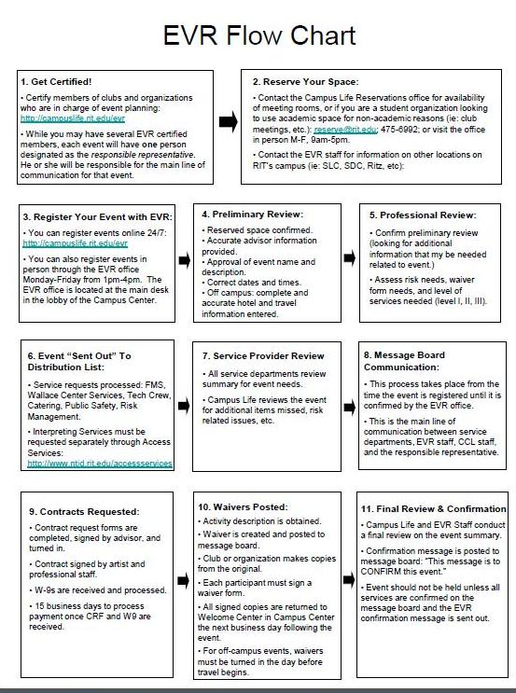

Reserving Space on Campus
The first thing that needs to happen before an event can be registered or even occurs is that the space needs to be RESERVED. If you’re holding an event on campus, you need to reserve the space first. If you’re holding an event off campus, you don’t need to reserve the space, but you DO need to REGISTER the event!

The Campus Center Reservation Desk is open M-F, 9am-5pm, and you can reserve a location at that time. From there, you can then register your event. Event Registration won’t even occur until the space has actually be reserved.

Reserving Athletic Facilities ON Campus:
http://www.rit.edu/studentaffairs/criw/club-sports.php

To request space at the SLC, Clark Gym, or Outdoor Fields:
- Call 585.475.7663
- Email slcciar@rit.edu
- Visit the SLC Main Office
  - Monday: 9am-4pm
  - Tuesday: 9am-6:30pm
  - Wednesday: 9am-6:30pm
  - Thursday: 9am-4pm
  - Friday: 9am-4pm
- Online requests for special events (NOT reoccurring practices) can be made by filling out the form at: http://www.rit.edu/studentaffairs/criw/club-sports.php

To request a space at the Gordon Field House or Aquatics Center:
- Complete an online request at: https://www.rit.edu/fa/fieldhouse/recreation_reservation.php
Listed below are generally the times that are available for club reservations in a particular location.
Location | Day | Time
Turf Field | Friday | 8pm - 11pm
 | Saturday | Noon - 11pm
 | Sunday (durning week 1 & 2 of each semester only) | Noon - 11pm
Student Life Center | Monday - Friday | 6am - 11pm (with limited time before 6pm)
 | Saturday | 8am - 11pm
 | Sunday | 10am - 11pm
Clark & Auxiliary Gyms | Monday - Friday | 8:30pm - 10:30pm
 | Saturday | Noon - 11pm (by special request, staff charges may apply)
 | Sunday | Noon - 11pm (by special request, staff charges may apply)

RULES:
- All Club Sports are allotted two hours of reserved recreation time per week.
- Once a club has used their reservation quota, the facilities are available on a first come first served basis. (except Martial Arts/Fencing Clubs)
- A club must provide a start and end date for their reservation request.
- During peak hours, when a club does not have a reservation, they cannot monopolize space for more than one hour. This ensures that others have the opportunity to recreate as well.
- Clubs must have at least 10 participants in order to hold a reservation. If turnout is consistently low for a particular club, future reservations for the club will be cancelled.
- For special events (games/tournaments), clubs must reserve space before registering the event with EVR.
Martial Arts / Fencing Clubs
Participation in any martial arts activity, with or without weapons, must take place in the presence of an approved instructor during an activity class or club reservation time. These clubs may not practice without the presence of an approved instructor for their specific club.
Roller Hockey Club
Court 5, in the Student Life Center, is a temporary location in order to accommodate roller hockey reservations. There are several rules that must be followed in order for this to occur. Please contact Brennan Coon for details.

Additional Event guidelines

BBQ Food Safety Guidelines:

Thaw Safety
Completely thaw meat and poultry before grilling it so it cooks more evenly. Use the refrigerator for slow, safe thawing or thaw sealed packages in cold, running water. Do not thaw at room temperature.

Transporting
When carrying food to another location, keep it cold to minimize bacterial growth. Use an insulated cooler with sufficient ice or ice packs to keep the food at 40 F or below. Pack food right from the refrigerator into the cooler immediately before leaving home.

Keep Cold Food Cold
Keep meat refrigerated until ready to use. Only take out the meat that will immediately be placed on the grill. Don’t take ready to eat foods out until you need them. Cold food should be less than 40 degrees.

Keep Everything Clean
Be sure there are plenty of clean utensils and platters. To prevent foodborne illness, don’t sue the same platter and utensils for raw and cooked meat. Harmful bacteria present in raw meat their juices can contaminate safely cooked food.

Wash Your Hands
Wash your hands properly between touching raw and cooked food. You should be wearing gloves when touching ready to eat food.

Cook Thoroughly
Cook food to a safe minimum internal temperature to destroy harmful bacteria. Meat cooked on a grill often browns very fast on the outside. Use a food thermometer to be sure the food has reached a safe minimum internal temperature of 160 degrees.

Keep Hot Food Hot
After cooking meat on the grill, keep I and hot dishes hot until served- at 140 degree or warmer.

Serving the Food
When taking food off the grill, use a clean platter. Don’t put cooked food on the same platter that held raw meat. Wear gloves to serve ready to eat food. Wash your hands properly after touching anything dirty or raw product.

Leftovers
Refrigerate any leftovers promptly in shallow containers. Discard any food left out more than 2 hours (1 hour if temperatures are above 90 degrees). If you have any doubts, throw it out!

Additional Event guidelines

Raffle Rules and Approval Process:

Raffles are games of chance, in which people purchase consecutively numbered tickets for the chance to receive a prize. Raffles are governed by, and must be conducted in accordance with, all rules and regulations specified under state and local laws. New York law allows not-for-profit organizations to conduct raffles and Henrietta Town law requires that certain raffles conducted in the Town of Henrietta be licensed.

In order to determine if a raffle must be licensed, RIT requires that every raffle be approved by the RIT Office of Legal Affairs and the RIT Chief Risk and Compliance Officer before any tickets are sold. Certain RIT Departments may require additional approvals, as well. Assuming appropriate approvals have been obtained, the following rules apply:

- Raffle tickets should have the following items printed on their face:
  - Name (and identification number, if applicable) of the authorized organization
  - The location(s), date(s), and time(s) of the drawing(s)
  - The consecutively printed serial number of the ticket
  - The price of the ticket
  - A list of the prizes offered
  - The statement: “Ticket holders need not be present to win.”
  - Each ticket stub of receipt shall reflect the name, address and telephone number of the ticket purchasers, and the consecutively printed serial number of the ticket.

- No single prize shall exceed the sum of $5,000. The value of the prize to be determined as the fair market value as of the date of the drawing.

- Only persons eighteen years of age or older shall purchase raffle tickets, sell raffle tickets or conduct or assist in the administration of a raffle drawing.

- The method of drawing and determining the winning ticket(s) shall be clearly announced and described prior to drawing a ticket.

- Each drawing shall be conducted openly and in plain view of the ticket purchasers present.

- No ticket shall be sold in conjunction with any raffle more than 180 days prior to the date scheduled for the drawing of the last ticket in that raffle.

- All raffle tickets shall be sold at a uniform price per ticket.

- Records of the raffle (financial accounting, tickets sold, names(s) of winners, accounting of aggregate fair market values or prizes, advertising, etc.) shall be maintained for six years.

If the aggregate fair market value of all prizes for all raffles conducted in one calendar year at RIT exceeds $20,000 you will not be allowed to conduct the raffle.

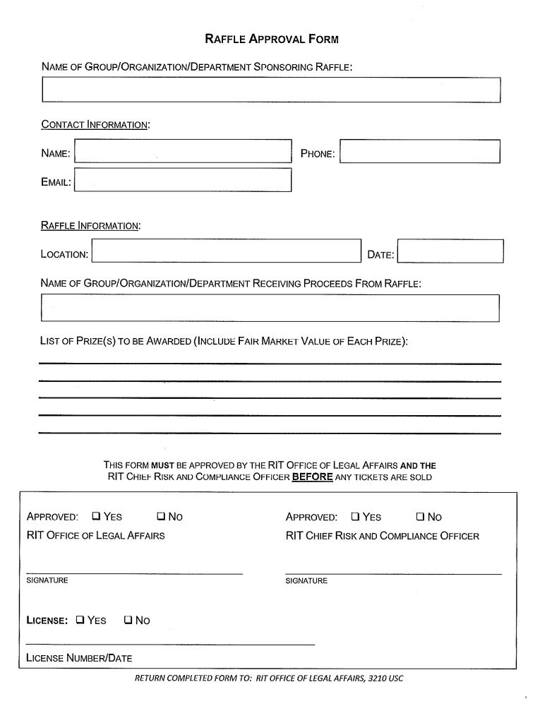
Additional Event guidelines

Movies & Copyright Law:

Federal Copyrights Laws:

- The Feral Copyright Act (Title 17, United States code, Public Law 94-553, 90 Sat. 2541) governs how copyrighted materials, such as movies, may be utilized publicly. Neither the rental nor the purchase or lending of a videocassette or DVD carries with it the right to exhibit such as movie publicly outside the home, unless the site where the video is used is properly licensed for copyright compliant exhibition.

- This legal copyright compliance requirement applies to parks and recreation departments, colleges, universities, public schools, day care facilities, summer camps, churches, private clubs, prisons, lodges, businesses, etc. regardless of whether admission is charged, whether the institution is commercial or nonprofit or whether a federal, state or local agency is involved.

- The movie studios, who own copyrights, and their agents, are the only parties who are authorized to license sites such as parks and recreation departments, businesses, museums, etc. No other group or person has the right to exhibit or license exhibitions of copyrighted movies.

- Furthermore, copyrighted movies borrowed from other sources such as public libraries, colleges, personal collections, etc. cannot be used legally for showing in colleges or universities or in any other site which is not properly licensed.

Face to Face Teaching Exemption:

Under the “education exemption.” Copyrighted movies may be exhibited in a college without a license only if the movie exhibition is:
- An integral part of a class session and is of material assistance to the teaching content.
- Supervised by a teacher in a classroom.
- Attended ONLY by students enrolled in a REGISTERED class of an accredited nonprofit educational institution.
- Presented using a lawfully made movie that has been legally produced and obtained through rental or purchase.

Those who violate copyright law are subject to consequences:
- Willful infringement
  - Maximum sentence of up to one year in jail
  - And/or a $100,000 fine
- Inadvertent infringers
  - Civil damages, ranging from $500 to $20,000 for each illegal showing

To purchase the license for showing a movie on RIT’s campus, contact Matt Flinner with Swank Motion Pictures (mflinner@swankmp.com/ 1-800-876-3344).

Any student event involving the showing of a movie must be registered with Event Registration through the Center for Campus Life: http://campuslife.rit.edu/evr. Proof of license purchase will be required before events are confirmed.
Additional Event guidelines

Movies & Copyright Law:

Frequently Asked Questions:

Q: What is considered public space on our campus?
A: Anything outside of the personal residence hall room or apartment is considered public space (ie: classrooms, auditoriums, meeting/conference rooms, libraries, museums, recreational facilities, common areas of apartments/ and other residential communities, outdoor pace, cafeterias, etc.). A public space is one that is accessible to ALL members of the general public. It does not have to be accessible to them 24hours/7 days a week, but needs to be accessible during the time that the movie is being shown. If only certain people are allowed access, then it is not a public space.

Q: If I’m not charging admission to watch the movie, do I still need to purchase the licensing rights?
A: Yes. A license is required for all public performances regardless of whether admission is charged.

Q: If I buy a movie at Target, rent it from the library, or already own the film, does that count as “purchasing the rights”?
A: No. Stores and libraries sell and rent movies for “home use only” and cannot provide legal permission for use outside of the home. You can only obtain licensing directly from a licensor, not from a third party.

Q: What if I want to show an old movie from the ‘30s or ‘40s? Do I still need a license?
A: Yes. Copyright pertains to all movies regardless of the year it was produced, unless it falls in the “public domain” and is free for viewing. To see a list of movies in this category, visit: www.openflix.com.

Q: What if I’m only showing the film to a small group of friend or classmates? Do I still need a license?
A: If the movie is being shown outside your home, a license needs to be obtained regardless of the number of people attending the screening.

Q: My organization is showing the film for educational purposes. Do I still need a license?
A: You will need to purchase the license unless your movie is being shown as part of a class and is relevant to teaching content, the movie is supervised by the course instructor, and the movie is attended ONLY by students enrolled in a REGISTERED class at RIT. Showing a movie outside of a classroom and holding an education discussion following the film is not part of the face-to-face teaching exemption.

Q: What am I paying for when I purchase the rights to a movie?
A: The license fees compensate the copyright owners and the men and women who work on the film’s production. These royalties are the way publishers, authors, composers, musicians, inventors, computer programmers and movie produces are paid for their work.

Q: Do documentaries and independent films fall under the same rules?
A: These types of movies are usually explored on a case by case basis. Sometimes permission can be obtained from the film maker to show the film without purchasing the rights. Please contact the Event Registration office for more information: evrccl@rit.edu.

RIT Helpful Website Links

Center for Campus Life:
http://campuslife.rit.edu

Clubs and Organizations:
http://clubs.rit.edu

How to Form A Club:
http://campuslife.rit.edu/main/form_club/index

Budgeting Resources, Documents, Applications, Referrals:
http://campuslife.rit.edu/main/clubs/resources

RIT Club Finance Certification:
http://campuslife.rit.edu/cfc/cfc.swf

Free Marketing: Staff Artist Request:
https://webapps.rit.edu/cas/login?service=http://campuslife.rit.edu/main/art_request/displayForm

RIT Events Calendar:
http://events.rit.edu

Event Registration:
http://campuslife.rit.edu/evr

RIT Homepage:
http://rit.edu:

College Activities Board:
http://cab.rit.edu

Student Government:
http://www.sg.rit.edu

My RIT Portal:
http://my.rit.edu
(find your UID here)

The Link@RIT:
http://thelink.rit.edu

